french_fragrance_db — Table Structures

Overview
The competitor price tracker keeps everything in one Postgres database on Render, french_fragrance_db, in 17 tables.

Tables
Table | What it holds | Created by | Rows (15 Oct)
competitor_table | Our products, every competitor's link / price / stock, least price, suggested price, LOP / MOP | app.py (CT_CREATE) + price_limits.py | 9,544
french_fragrance_catalog | All French Fragrance products | migrate_ff_catalog.py | 15,294
branded_perfume_catalog | The same products on Branded Perfume | branded_perfume.py | 15,294
essenzi_catalog | The same products on Essenzi | essenzi.py | 15,294
samawa_catalog | Samawa full product list | samawa_catalog.py | 26,714
vperfumes_catalog | V Perfumes full product list | vperfumes.py | 8,491
alinjaz_catalog | Al Injaz full product list | alinjaz.py | 1,462
ounass_catalog | Ounass full product list | ounass.py | 3,235
amberiya_catalog | Amberiya full product list | amberiya.py | 3,153
nichegallerie_catalog | Niche Gallerie full product list | nichegallerie.py | 5,906
app_settings | Settings and run progress (discount rate, daily run, Run 2) | discount_rate.py, competitors_page.py, daily_update.py | few
brand_automation | Which brands are on automatic price | app.py | few
app_users | Website logins | auth.py | few
price_check_runs | One row per run of the old daily price check | price_check.py | —
price_check_log | Every link that price check opened | price_check.py | —
price_check_progress | Last check per product | price_check.py | —
test_price_backup | Real French Fragrance price saved by test_price.py, so undo can put it back | test_price.py | 0 after undo

competitor_table
One row per product of ours (from French Inventories in Airtable); the key is fi_record_id. Each competitor has its own group of columns with the same pattern.
Our product
Column | Type | Meaning
id | SERIAL | Row number
fi_record_id | TEXT, unique | Airtable record id (recXXX) of the product
french_inventory_code | TEXT | Code in French Inventories
sku | TEXT | Our SKU, e.g. AMF1085
product_name | TEXT | Full product name
perfume_name | TEXT | Perfume name without brand / size
brand | TEXT | Brand
barcode | TEXT | Barcode (GTIN)
uae_price | NUMERIC(10,2) | Our UAE price (AED)
our_link | TEXT | Product link on fragrantsouq.com
our_title | TEXT | Product name on our site
our_stock | BOOLEAN | In stock on our site
updated_at | TIMESTAMP | Last change of the row
Per competitor (prefix = samawa, ff, bp, es, vp, aj, on, am, ng)
Column | Type | Meaning
<prefix>_link | TEXT | Matched product page on that shop (empty = not matched)
<prefix>_price | NUMERIC(10,2) | Their price incl. 5% VAT
<prefix>_stock | BOOLEAN | TRUE = in stock
<prefix>_title | TEXT | Product name on that shop
<prefix>_suggestion | TEXT | Possible match waiting for OK / Not OK
<prefix>_method | TEXT | How it was matched (barcode, fuzzy, confirmed)
<prefix>_score | NUMERIC(5,3) | Name-match score 0–1
<prefix>_confirmed | BOOLEAN | TRUE = a person clicked OK
<prefix>_rejected | TEXT | Link a person refused with Not OK (never suggested again)
Branded Perfume (bp) and Essenzi (es) only have _link, _price, _stock and _title: they follow the French Fragrance match.

Prices and limits
Column | Type | Meaning
least_price | NUMERIC(10,2) | Cheapest of our price and every in-stock competitor
least_priced_website | TEXT | Every website with that price, e.g. "V Perfumes"
suggested_price | NUMERIC(10,2) | Cheapest in-stock competitor − discount rate, kept between LOP and MOP
LOP | NUMERIC(10,2) | Lowest allowed suggested price (empty = no limit)
MOP | NUMERIC(10,2) | Highest allowed suggested price (empty = no limit)
limits_by | TEXT | Who saved LOP / MOP last
limits_at | TIMESTAMP | When

French Fragrance, Branded Perfume, Essenzi
These three shops sell the same products. Branded Perfume and Essenzi rows point to their French Fragrance row through ff_id. Run 1(daily run by 10brands) on the PC updates their price and stock every working day.
french_fragrance_catalog
Column | Type | Meaning
id | SERIAL | Row number (= ff_id in the two tables below)
airtable_record_id | TEXT, unique | Record id from the old Airtable FF Catalog
product_url | TEXT | Product page on frenchfragrance.com
gtin | TEXT | Barcode
name | TEXT | Product name
price_inc_tax | NUMERIC(10,2) | Price incl. 5% VAT
price | NUMERIC(10,2) | Price without VAT
stock | TEXT | In stock / Out of stock / Not on site
volume | TEXT | e.g. 100 ml
updated_at | TIMESTAMP | Last change

essenzi_catalog (Branded Perfume: same columns, bp_ instead of es_)
Column | Type | Meaning
id | SERIAL | Row number
ff_id | INTEGER, unique | The product's id in french_fragrance_catalog
ff_url | TEXT | French Fragrance link (source)
gtin | TEXT | Barcode
name | TEXT | Product name (from French Fragrance)
volume | TEXT | e.g. 100 ml
es_url | TEXT | Same page on essenzi.com
es_price | NUMERIC(10,2) | Price without VAT
es_price_inc_tax | NUMERIC(10,2) | Price incl. 5% VAT
es_stock | TEXT | In stock / Out of stock / Not on site
es_status | TEXT | ok / not_found (why)
es_title | TEXT | Product name on Essenzi
es_size | TEXT | Size read from that name
checked_at | TIMESTAMP | When the page was last opened
updated_at | TIMESTAMP | Last change
The live branded_perfume_catalog has exactly these columns with bp_ (checked 15 Oct 2026).

Run 2 shop lists (daily run per one shop)
The six Run 2 shops share almost the same columns; each holds that shop's whole product list, refreshed one shop per day. A tick means the table has that column.
Column | Type | Meaning | Samawa | V Perfumes | Al Injaz | Ounass | Amberiya | Niche Gallerie
id | SERIAL | Row number | ✓ | ✓ | ✓ | ✓ | ✓ | ✓
variant_id | BIGINT, unique | Shopify variant id (one row per size) | ✓ |  |  |  | ✓
product_id | BIGINT | Shopify product id | ✓
product_url | TEXT | Product page (unique where there is no variant_id) | ✓ | ✓ | ✓ | ✓ | ✓ | ✓
gtin | TEXT | Barcode | ✓ | ✓ | ✓ | ✓ (empty) | ✓ | ✓
sku | TEXT | Their SKU / product number |  |  | ✓ | ✓ | ✓ | ✓
brand | TEXT | Brand as written on their site | ✓ |  |  | ✓ | ✓
name | TEXT | Product name | ✓ | ✓ | ✓ | ✓ | ✓ | ✓
product_type | TEXT | Shopify product type |  |  |  |  | ✓
price_inc_tax | NUMERIC(10,2) | Price shown on the site, incl. 5% VAT |  | ✓ | ✓ | ✓ | ✓ | ✓
price | NUMERIC(10,2) | Samawa: price shown. Others: without VAT (price_inc_tax ÷ 1.05) | ✓ | ✓ | ✓ | ✓ | ✓ | ✓
stock | TEXT | In stock / Out of stock / Not on site | ✓ | ✓ | ✓ | ✓ | ✓ | ✓
volume | TEXT | e.g. 100 ml | ✓ | ✓ | ✓ | ✓ | ✓ | ✓
updated_at | TIMESTAMP | Last change | ✓ | ✓ | ✓ | ✓ | ✓ | ✓
Table names: samawa_catalog, vperfumes_catalog, alinjaz_catalog, ounass_catalog, amberiya_catalog, nichegallerie_catalog.

Settings, automation and users
app_settings — one row per setting
Column | Type | Meaning
key | TEXT, primary key | Name of the setting
value | TEXT | Its value (a number, or JSON for run progress)
updated_by | TEXT | User or script that saved it
updated_at | TIMESTAMP | When

Key | What it stores | Saved by
discount_rate | Auto discount rate X in %, e.g. 3 | Settings → Auto discount rate
daily_update | Run 1 progress: brand position, today's brands, results, new products | daily_update.py on the PC
full_lists | Run 2 progress: today's shop, round start, done dates, results | daily_update.py inside the website
daily_brands_per_day | Brands per day for Run 1 (default 10) | Settings → Automate
daily_weekly_day | Day for the weekly full lists (0 = Monday) | Settings → Automate
brand_automation — brands whose UAE Price follows the suggested price in Airtable
Column | Type | Meaning
brand | TEXT, primary key | Brand name
auto | BOOLEAN | TRUE = automatic price
updated_by | TEXT | Who ticked / unticked it
updated_at | TIMESTAMP | When
app_users — website logins
Column | Type | Meaning
username | TEXT, primary key | Lower case, e.g. ahsana
password_hash | TEXT | Hashed password (the real password is never saved)
role | TEXT | admin or user
active | BOOLEAN | FALSE = disabled
created_by | TEXT | Admin who added the user
created_at | TIMESTAMP | When
last_login | TIMESTAMP | Last successful login
failed_logins | INT | Wrong passwords in a row
locked_until | TIMESTAMP | Locked until this time after too many wrong passwords

Triggers and checking the live structure
Two kinds of database trigger (db_triggers.py, installed when the website starts) keep prices in step:
- copy_to_competitor on each of the 9 shop lists: a price or stock change is copied into competitor_table (<prefix>_price, <prefix>_stock) for every product matched to that link.
- recalc_suggested_price on competitor_table: a competitor price / stock / link, our UAE price, LOP or MOP change recalculates least_price, least_priced_website and suggested_price of that row.
competitor_table also has an index on each <prefix>_link so the copy is fast.
To see the live structure, run from the PC folder with sql.py:
python sql.py "SELECT table_name, column_name, data_type FROM information_schema.columns WHERE table_schema = 'public' ORDER BY table_name, ordinal_position" > tables.txt
python sql.py "SELECT event_object_table, trigger_name FROM information_schema.triggers"

How the tables connect?
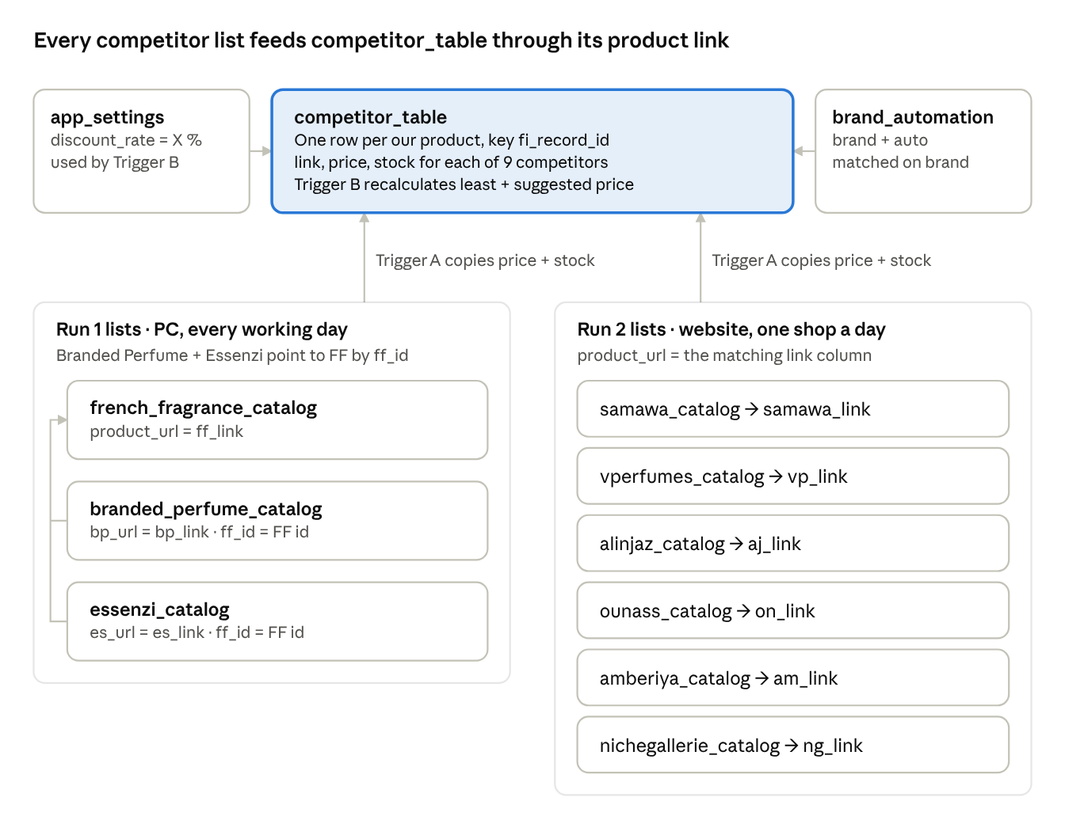

Indexes
Table | Unique (no duplicates allowed) | Search indexes
competitor_table | id, fi_record_id | sku, brand, and one per competitor link: samawa_link, ff_link, bp_link, es_link, vp_link, aj_link, on_link, am_link, ng_link (used by the triggers)
french_fragrance_catalog | id, airtable_record_id | gtin
branded_perfume_catalog | id, ff_id | gtin
essenzi_catalog | id, ff_id | gtin
samawa_catalog | id, variant_id | gtin
amberiya_catalog | id, variant_id | —
vperfumes_catalog | id, product_url | —
alinjaz_catalog | id, product_url | —
ounass_catalog | id, product_url | —
nichegallerie_catalog | id, product_url | —
app_settings | key | —
brand_automation | brand | —
app_users | username | —
price_check_runs | run_id | —
price_check_log | id | run_id; fi_record_id + checked_at
price_check_progress | fi_record_id | —
test_price_backup | ff_link | —

